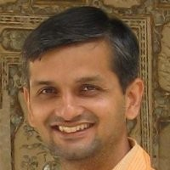

Samir Raiyani – President & CEO
MS in Computer Science from Stanford University
Samir is an experienced entrepreneur in innovative high technology and information services businesses. Prior to Dolcera, Samir was a Director at SAP Research where he led teams in innovation and market development, collaborating with SAP product groups and external partners to develop new applications including Wi-Fi networks for emergency response, RFID sensors for asset tracking, and multimodality.
Earlier in his career, he was a founder at MediSpark, a mobile healthcare startup sold to iScribe (now part of CareMark Corp.), and a software engineer at Broadbase.

Samir Raiyani
总裁兼首席执行官|Dolcera corporation
硕士|斯坦福大学计算机科学专业
Samir是一位在创新高科技和信息服务业务领域中有着丰富经验的企业家，现任美国专利检索和数据分析公司Dolcera CEO。
曾担任SAP Research的董事，带领创新和市场开发团队，与SAP产品组和外部合作伙伴协作开发新的应用程序，包括用于紧急响应的Wi-Fi网络，和用于资产跟踪和多模态的RFID传感器。
曾是MediSpark的创始人，MediSpark是一家出售给iScribe（现为CareMark Corp.的一部分）的移动医疗保健初创公司。

